**Ideation Phase**

**Define the Problem Statements**

|  |  |
| --- | --- |
| Date | 16 June 2025 |
| Team ID | LTVIP2025TMID46365 |
| Project Name | Book Nest |
| Maximum Marks | 2 Marks |

**Customer Problem Statement:**

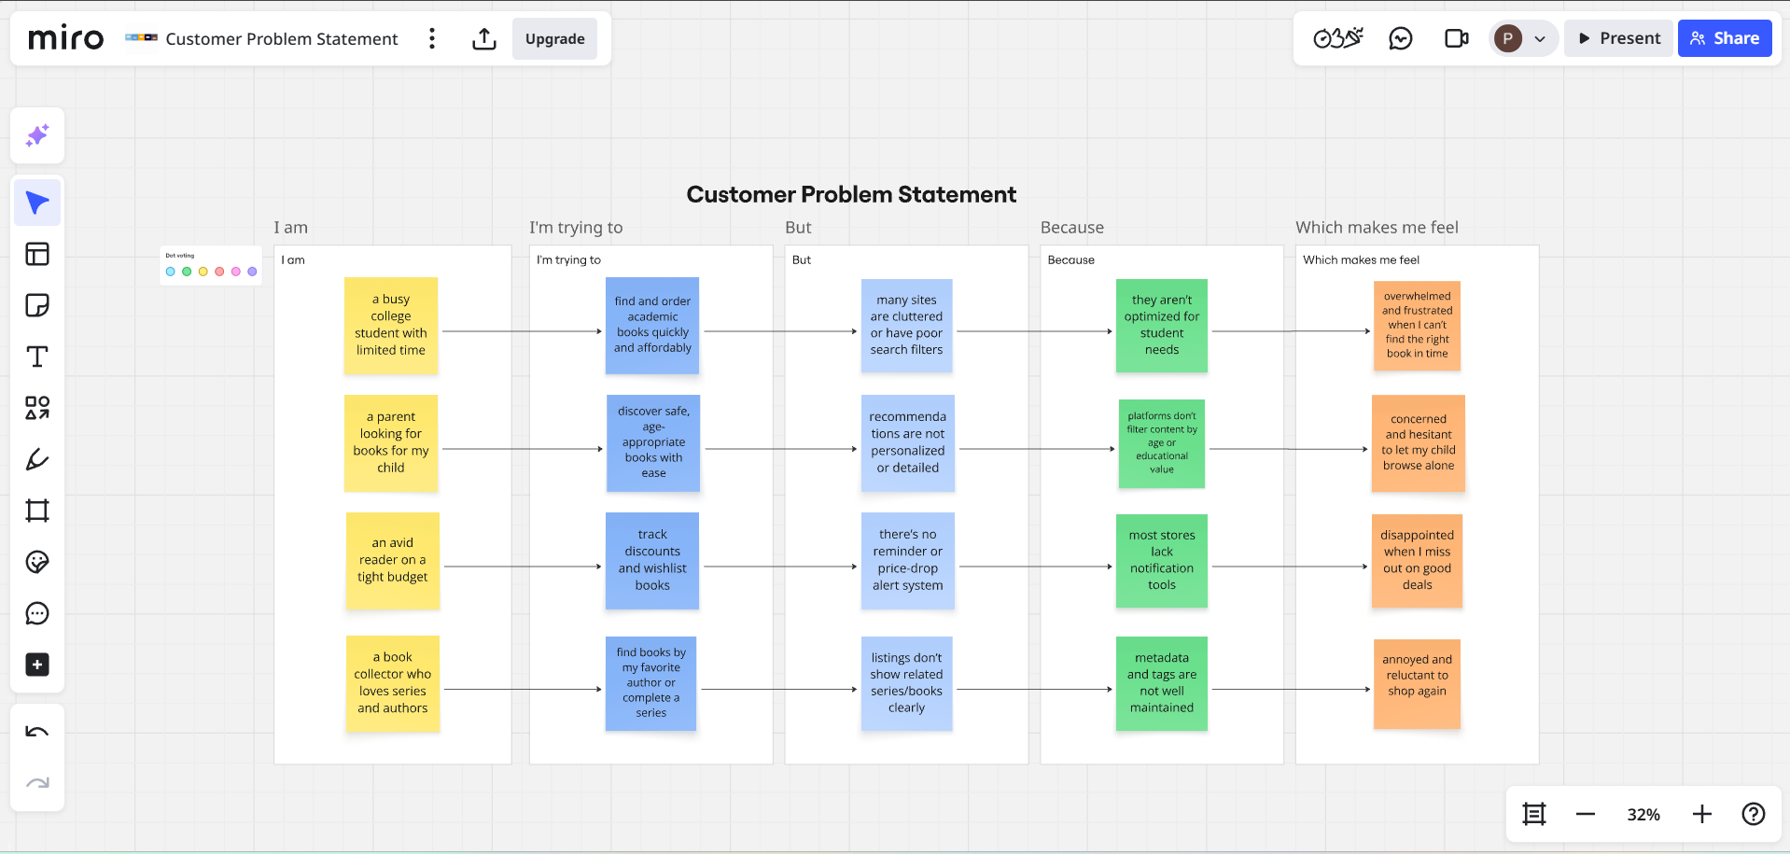Link: <https://miro.com/app/board/uXjVIkhiyxk=/?share_link_id=744776086381>

|  |  |  |  |  |  |
| --- | --- | --- | --- | --- | --- |
| **Problem Statement (PS)** | **I am (Customer)** | **I’m trying to** | **But** | **Because** | **Which makes me feel** |
| **PS-1** | a busy college student with limited time | find and order academic books quickly and affordably | many sites are cluttered or have poor search filters | they aren’t optimized for student needs | overwhelmed and frustrated when I can’t find the right book in time |
| **PS-2** | a parent looking for books for my child | discover safe, age-appropriate books with ease | recommendations are not personalized or detailed | platforms don’t filter content by age or educational value | concerned and hesitant to let my child browse alone |
| **PS-3** | an avid reader on a tight budget | track discounts and wishlist books | there’s no reminder or price-drop alert system | most stores lack notification tools | disappointed when I miss out on good deals |
| **PS-4** | a book collector who loves series and authors | find books by my favorite author or complete a series | listings don’t show related series/books clearly | metadata and tags are not well maintained | annoyed and reluctant to shop again |